Final Architecture (MVP)
Stack
- Frontend: React (Vite), role-based UI
- Backend: Node.js + Express
- Database: MySQL (or PostgreSQL)
- Auth: JWT (short-lived access token)
- Upload format: CSV (question,answer,level)
System Diagram
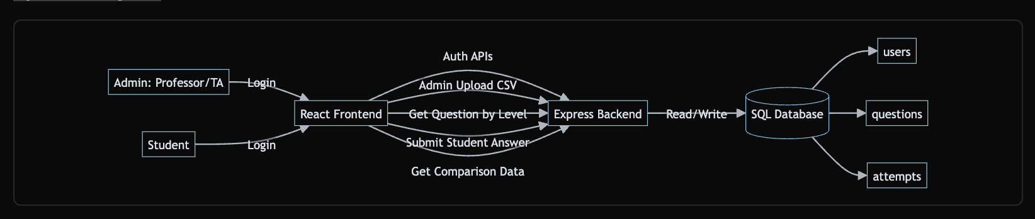
Final Data Model
users
- id (PK)
- name
- email (unique)
- password_hash
- role (admin / student)
- created_at, updated_at
questions
- id (PK)
- question_text
- answer_text
- level (1-6)
- created_by (FK -> users.id)
- created_at, updated_at
attempts
- id (PK)
- student_id (FK -> users.id)
- question_id (FK -> questions.id)
- student_answer
- submitted_at

Final API Contract (MVP)
Auth
- POST /auth/login
Input: email, passwordOutput: token + role + basic user info
Admin
- POST /admin/questions/upload (CSV file)
- GET /admin/questions?level=1 (optional but useful)
Student
- GET /student/levels (returns 1..6)
- GET /student/questions/random?level=1
- POST /student/attempts
- GET /student/attempts/:id/comparison

UI Pages (MVP)
Common
- Login page
- Role-based redirect
Admin
- Upload CSV page
- Upload result summary (rows inserted/failed)
Student
- Level selection page (1-6)
- Question answer page (text input)
- Comparison page (correct answer vs student answer side-by-side)

4-Day Deliverables (Final)
Day 1 — Foundation
- Project scaffolding (frontend + backend)
- DB created with 3 tables
- Auth login working for admin/student
- JWT + role middleware ready
Deliverable: login works and protected routes enforce role
Day 2 — Admin Upload
- CSV upload endpoint complete
- CSV parser + validations (level 1..6, non-empty fields)
- Questions inserted into DB
- Admin upload UI connected
Deliverable: admin can upload quiz file and data persists
Day 3 — Student Quiz Flow
- Level selection UI
- Fetch random question by level
- Submit answer and store attempt
- Comparison screen implemented
Deliverable: student completes one full quiz attempt flow
Day 4 — Stabilize + Demo
- End-to-end testing (admin + student)
- Error handling improvements
- Minor UI polish
- Seed/demo data + walkthrough prep
Deliverable: submission-ready MVP + demo script

Definition of Done (for your submission)
- Admin uploads questions via file
- Student selects level and answers
- App stores student answer
- App shows original vs student answer side-by-side
- SQL DB contains question, answer, level through questions table
- Role-based access works
Extras:
-- 1) USERS: #Admin + Students
CREATE TABLE users (
id INT AUTO_INCREMENT PRIMARY KEY,
name VARCHAR(100) NOT NULL,
email VARCHAR(150) NOT NULL UNIQUE,
password_hash VARCHAR(255) NOT NULL,
role ENUM('admin', 'student') NOT NULL,
created_at TIMESTAMP DEFAULT CURRENT_TIMESTAMP,
updated_at TIMESTAMP DEFAULT CURRENT_TIMESTAMP ON UPDATE CURRENT_TIMESTAMP
);

-- 2) QUESTIONS:# Question bank uploaded by admin
CREATE TABLE questions (
id INT AUTO_INCREMENT PRIMARY KEY,
question_text TEXT NOT NULL,
answer_text TEXT NOT NULL,
level TINYINT NOT NULL,
created_by INT NOT NULL,
created_at TIMESTAMP DEFAULT CURRENT_TIMESTAMP,
updated_at TIMESTAMP DEFAULT CURRENT_TIMESTAMP ON UPDATE CURRENT_TIMESTAMP,
CONSTRAINT chk_level CHECK (level BETWEEN 1 AND 6),
CONSTRAINT fk_questions_created_by
FOREIGN KEY (created_by) REFERENCES users(id)
ON DELETE RESTRICT ON UPDATE CASCADE
);

-- 3) ATTEMPTS: #Student submitted answers
CREATE TABLE attempts (
id INT AUTO_INCREMENT PRIMARY KEY,
student_id INT NOT NULL,
question_id INT NOT NULL,
student_answer TEXT NOT NULL,
submitted_at TIMESTAMP DEFAULT CURRENT_TIMESTAMP,
CONSTRAINT fk_attempts_student
FOREIGN KEY (student_id) REFERENCES users(id)
ON DELETE CASCADE ON UPDATE CASCADE,
CONSTRAINT fk_attempts_question
FOREIGN KEY (question_id) REFERENCES questions(id)
ON DELETE CASCADE ON UPDATE CASCADE
- );
DAY1:
Set up backend project in backend/ using Node + Express.
- Connected backend to MySQL using mysql2 and verified DB connection.
- Added env config (.env) and changed port to 5050 because 5000 was already used by macOS.
- Built auth endpoint POST /auth/login:
- checks email/password
- validates hashed password
- returns JWT token + user role
- Added middleware for:
- token verification (requireAuth)
- role-based access (requireRole)
- Added basic test routes:
- /health (works)
- /admin/ping (admin only)
- /student/ping (student only)
- Updated seeded DB passwords from TEMP_HASH to bcrypt hashes so login works.
So Day 1 outcome: backend base is ready, auth is working, and we can start Day 2 (admin CSV upload).

